Correct

Partially Correct (0.71)

Partially Correct (0.71)

Partially Correct (0.4285)

Correct

Correct

Correct

Correct

Correct

Correct

Correct

Correct

Correct

Correct

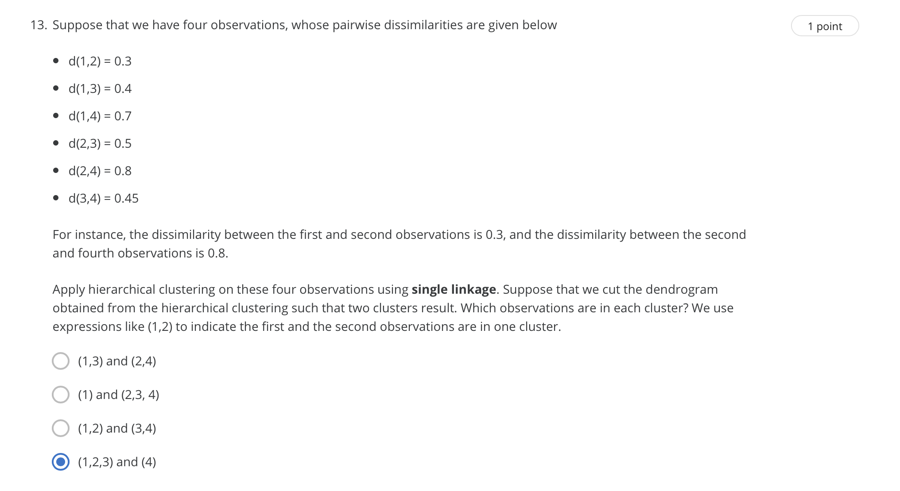

Answer: 1

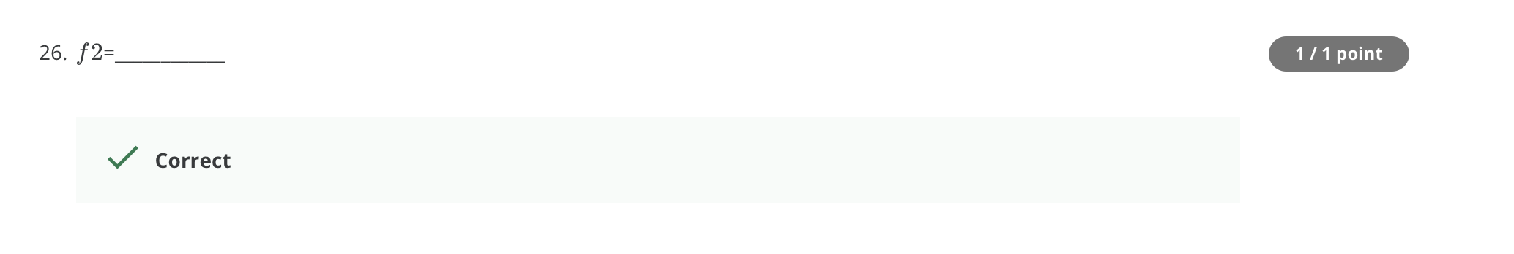

Answer: 6

